**SQL COMMANDS**

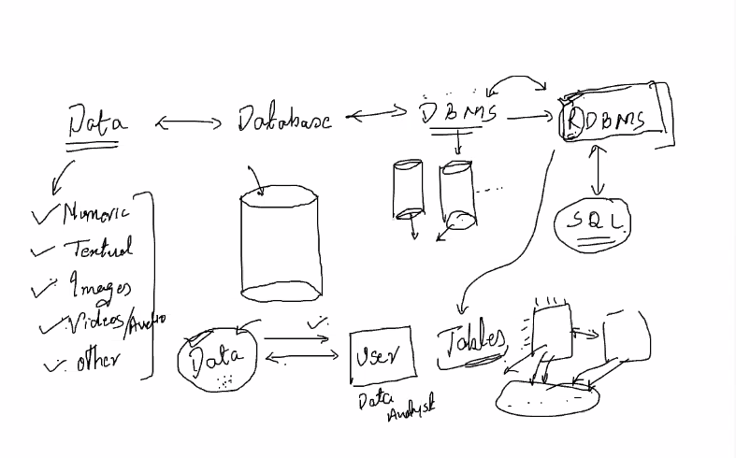

Create Database

* create database <database-name>;

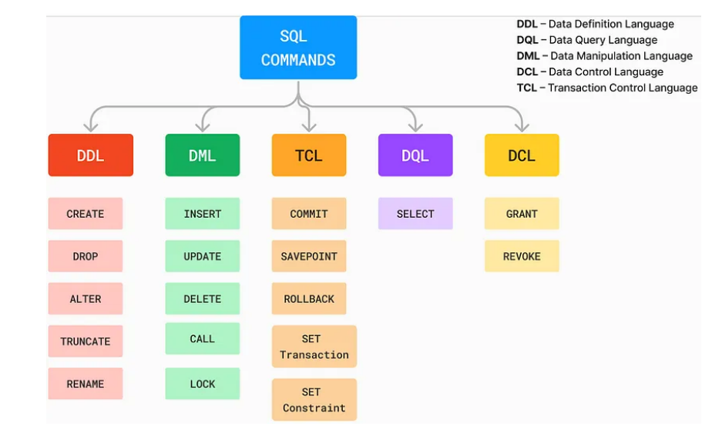

Drop Database

* drop database <database-name>;

Create Table

* create table <table-name> (column-name dtype);
* E.g=

-use <database-name>;

-create table courses (Course_id char(5), Course_Title varchar(30), Time_duration int, Student_intake int);

Drop Table

* drop table <table-name>;

Select all data from table

* select * from <table-name>

Alter the table

**I want to add a column**

* Alter table <table-name> add column <column-name> dtype;
* E.g= Alter table Courses add column Mode_of_delivery Varchar(40);

**I want to change a column**

* Alter table <table-name> Change column <old-column-name> <new-name> varchar(20);
* E.g= = Alter table Courses Change column Mode_of_delivery Delievery_mode Varchar(20);

CONSTRAINTS

* Constrainsts means restrictions
* Contrainsts are
* Primary key
* Foreign key
* Unique
* Not Null
* Default

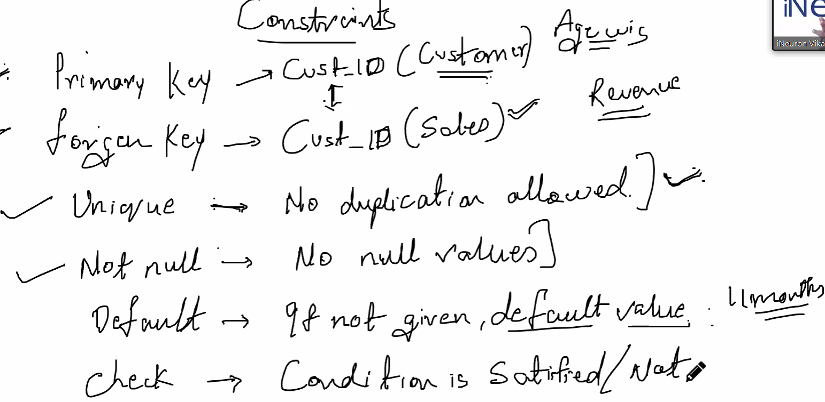

-Constraints will apply on column

-If we use primary constraint on the column then automatically unique and not null constraint is applied.

DIFFERENCE BETWEEN TRUNCATE AND DROP

-If we use truncate then all data which is in table will deleted.

-If we use drop then entire table is got deleted.

-Delete is use to delete specific rows

**DML**

INSERT

-Insert into <table-name>

values(first,second,third,….);

INSERT MULTIPLE VALUE

-Insert into <table-name>

Values(first,second,third column values,…),(first,second,third,……);

INSERT VALUE IN PARTICULAR COLUMN

-Insert into <table-name> (first column,second column)

Values(first value,second value)

**CONSTRAINTS**

Unique constraint

* Alter table <table-name> change column <old-name> <new-name> <dtype> Unique;

Not Null Constraint

* Alter table <table-name> change column <old-name> <new-name> <dtype> Not Null;

You make old-name and new-name of column same or you can change it also.

**Note=**

1)Update is for row level

2)Alter is for column level